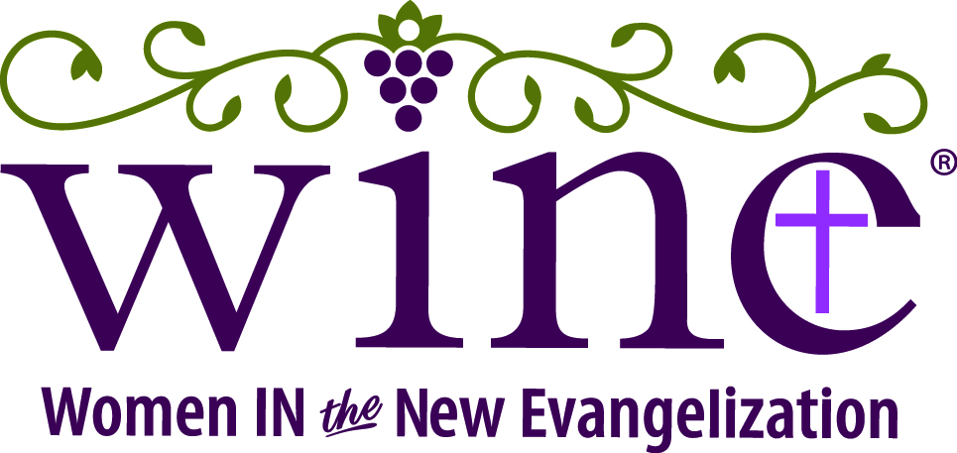

Pulpit Announcement
2018 NOLA WINE: Catholic Women’s Conference
Anchor of Hope
Good morning/evening. My name is [name] and I am a parishioner here at [parish]. I am here to offer a special invitation to all the women of our parish to join me for the 2018 WINE: Catholic Women’s Conference on Saturday, June 9th. This is the second time that WINE, a National Women’s Ministry will host a conference for women in the Archdiocese of New Orleans, and we’ll be welcoming women from across the country!
At the conference, dynamic Catholic speakers ValLimar Jansen and Renee Bondi will inspire you and musician Lorraine Hess will rejuvenate your spirit. The day will include time for confession, to pray with prayer teams, rest, socializing, and shopping. It will be a time to step away from the daily routine, connect with God and with friends, and let your heart be restored with hope.
The conference will take place on Saturday, June 9, 2018, 9:30am-3:30pm at St. Angela Merici in Metairie with Mass at 4pm with Archbishop Aymond. In 2016, we saw over 400 women come together for the first NOLA WINE: Catholic Women’s Conference, and this year we are expecting over 700 women! With that in mind, I recommend that you register as soon as possible. There is a special group discount rate available, so bring your friends!
[If applicable, add here information about ways your parish is organizing registration.]
For more information & to register, visit wineconference.org

