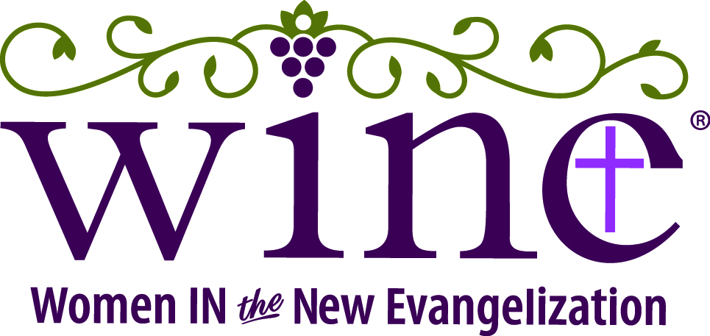

2024 WINE: Catholic Women's Conference
"A Spiritual Spa: Come to the Living Waters"
Saturday, July 27, 2024
(Friday evening option on July 26)

Ladies, you are invited to the 4th annual Baton Rouge WINE: Catholic Women's Conference at Our Lady of Mercy, “A Spiritual Spa: Come to the Living Waters,” on Saturday, July 27, 2024.

Beginning at 8:00 a.m. with Mass celebrated by Bishop Duca, the conference includes inspirational talks, faith-filled entertainment, opportunities for confession, adoration, shopping, and prayer with a prayer team. There will also be tons of laughter, a fabulous lunch, more shopping, chocolate, and a fun raffle.

An optional fantastic evening "Gathering in the Vineyard" on Friday, July 26, will bring together women passionate about living out the New Evangelization for a fantastic meal and fellowship at Drusilla Seafood. (Space is limited.)

Invite a friend or three and register today at SpiritualSpa2024.eventbrite.com. Early Bird pricing ends June 27, 2024. Special pricing for religious, consecrated women, and students. For more information, visit WINEconference.org.

Web banner and conference images are available at WINEconference.org
------------------------------------------------------------------------------------------------------------------------------------------------------

2024 WINE: Catholic Women's Conference
"A Spiritual Spa: Come to the Living Waters”
Saturday, July 27, 2024
(Friday evening option on July 26)

Ladies, you are invited to the 4th annual Baton Rouge WINE: Catholic Women's Conference at Our Lady of Mercy, “A Spiritual Spa: Come to the Living Waters,” on Saturday, July 27, 2024.

Beginning at 8:00 a.m. with Mass celebrated by Bishop Hebda, the conference includes inspirational talks by Louisiana native Anne Trufant, founder of WINE, Kelly Wahlquist, and actress and singer Maria Vargo. There will be opportunities for confession, adoration, shopping, and prayer teams, along with tons of laughter, a fabulous lunch, more shopping, CHOCOLATE, and a fun raffle.

An optional evening, "Gathering in the Vineyard" at Drusilla Seafood on Friday, July 26, will bring together women passionate about actively living out the New Evangelization. The evening will include a tremendous dinner, praise and worship, networking, entertainment, and a few surprises. (Space is limited to 80 people on Friday evening, so sign up early!)

Invite a friend or three and register today at SpiritualSpa2024.eventbrite.com - $110 for Friday Social Gathering & Saturday Conference or $65 for Saturday Conference if you register by June 27, 2024! Special pricing for religious, consecrated women, and students. For more information and to register, visit WINEconference.org.

