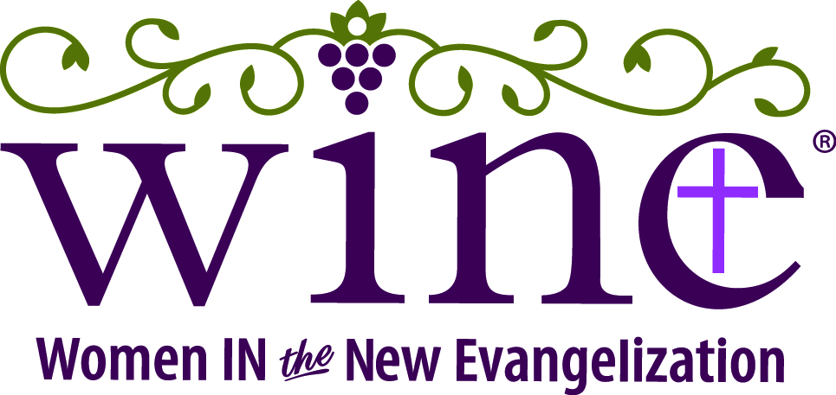

Bulletin Announcement
2020 WINE: Catholic Women’s Conference – Hawaii
Friday & Saturday, March 27 & 28

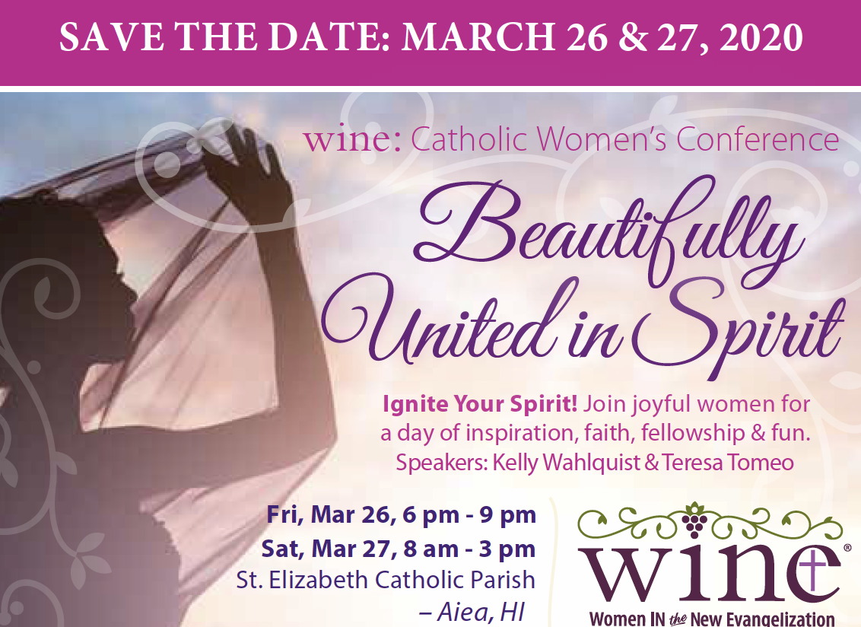

WINE: Women In the New Evangelization and the Diocese of Honolulu’s Evangelization Task Force invite you to the WINE: Catholic Women’s Conference on Friday & Saturday March 27 & 28, at St. Elizabeth Catholic Parish in Aiea, Hawaii

The conference theme, “Beautifully United in Spirit,” speaks to God’s providential plan for our lives and how He has beautifully united us in His Spirit to live out that plan at such a time as this. The conference, with emcee Michelle Nash, includes inspirational talks by Catholic author and WINE foundress, Kelly Wahlquist; and syndicated Catholic talk show host, author, and motivational speaker, Teresa Tomeo.

Friday evening begins with registration at 6:00 p.m. followed by Stations of the Cross, a light dinner, praise & worship and a healing service, and a social gathering to meet the speakers. Saturday begins with Mass at 7:00 a.m. followed by praise & worship music; inspirational talks; motivational entertainment; opportunities for confession, adoration, shopping, and prayer teams; tons of laughter; a fabulous lunch; CHOCOLATE; door prizes at the 3:00 PM conclusion!

Invite a friend or three and register today!

Conference cost $30 before March 19/$45 after.

